Date:_______________________________

PARTICIPANT COVENANT

As a participant of the Jamestown Area Youth Lock-Out, I agree to:

*SHOW RESPECT for myself and all other participants of this event as well as the facility, staff and property.

*PARTICIPATE in all parts of this weekend,

*NOT bring or use alcohol or other non-prescribed drugs including tobacco products. Trinity Lutheran Church is a tobacco free environment.

*ABIDE by curfew times and quiet hours,

*NOT use offensive language,

*NOT engage in sexual activity.

*NOT bring or use a cell phone
(Leaders may use their phones for emergency purposes only)
Student Signature:__________________________________________________

Parent/ Guardian Signature:__________________________________________

Adult Participant Signature:__________________________________________
Contact Person: Kirstie Dobson
Director of Youth Ministries
Trinity Lutheran Church, Jamestown, ND
kirstiedobson@yahoo.com
Cold. Lonely. Hungry. Tired. Angry. Hurt. Hopeless. Homeless.
Every day in Stutsman County a child goes to sleep hungry. Every day in Stutsman County a man couch surfs from friend to friend, to stave off the cold. Every day in Stutsman County an elderly person chooses between medicine and food. Every day in Stutsman County a parent cries because they cannot provide even the most basic of necessities for his/ her family.
So what are we to do? As caring and committed Christ followers, we are called to respond. In Luke 3:11, John is asked this very question: “Then what are we to do?” He responds, “If you have two coats, give one away and do the same with your food.” In Deuteronomy we are commanded, not asked, but commanded to do the same; to be generous, to be caring and to share what God has given.
The Youth of Trinity are inviting you to respond.

Jamestown Area Youth Lock-Out

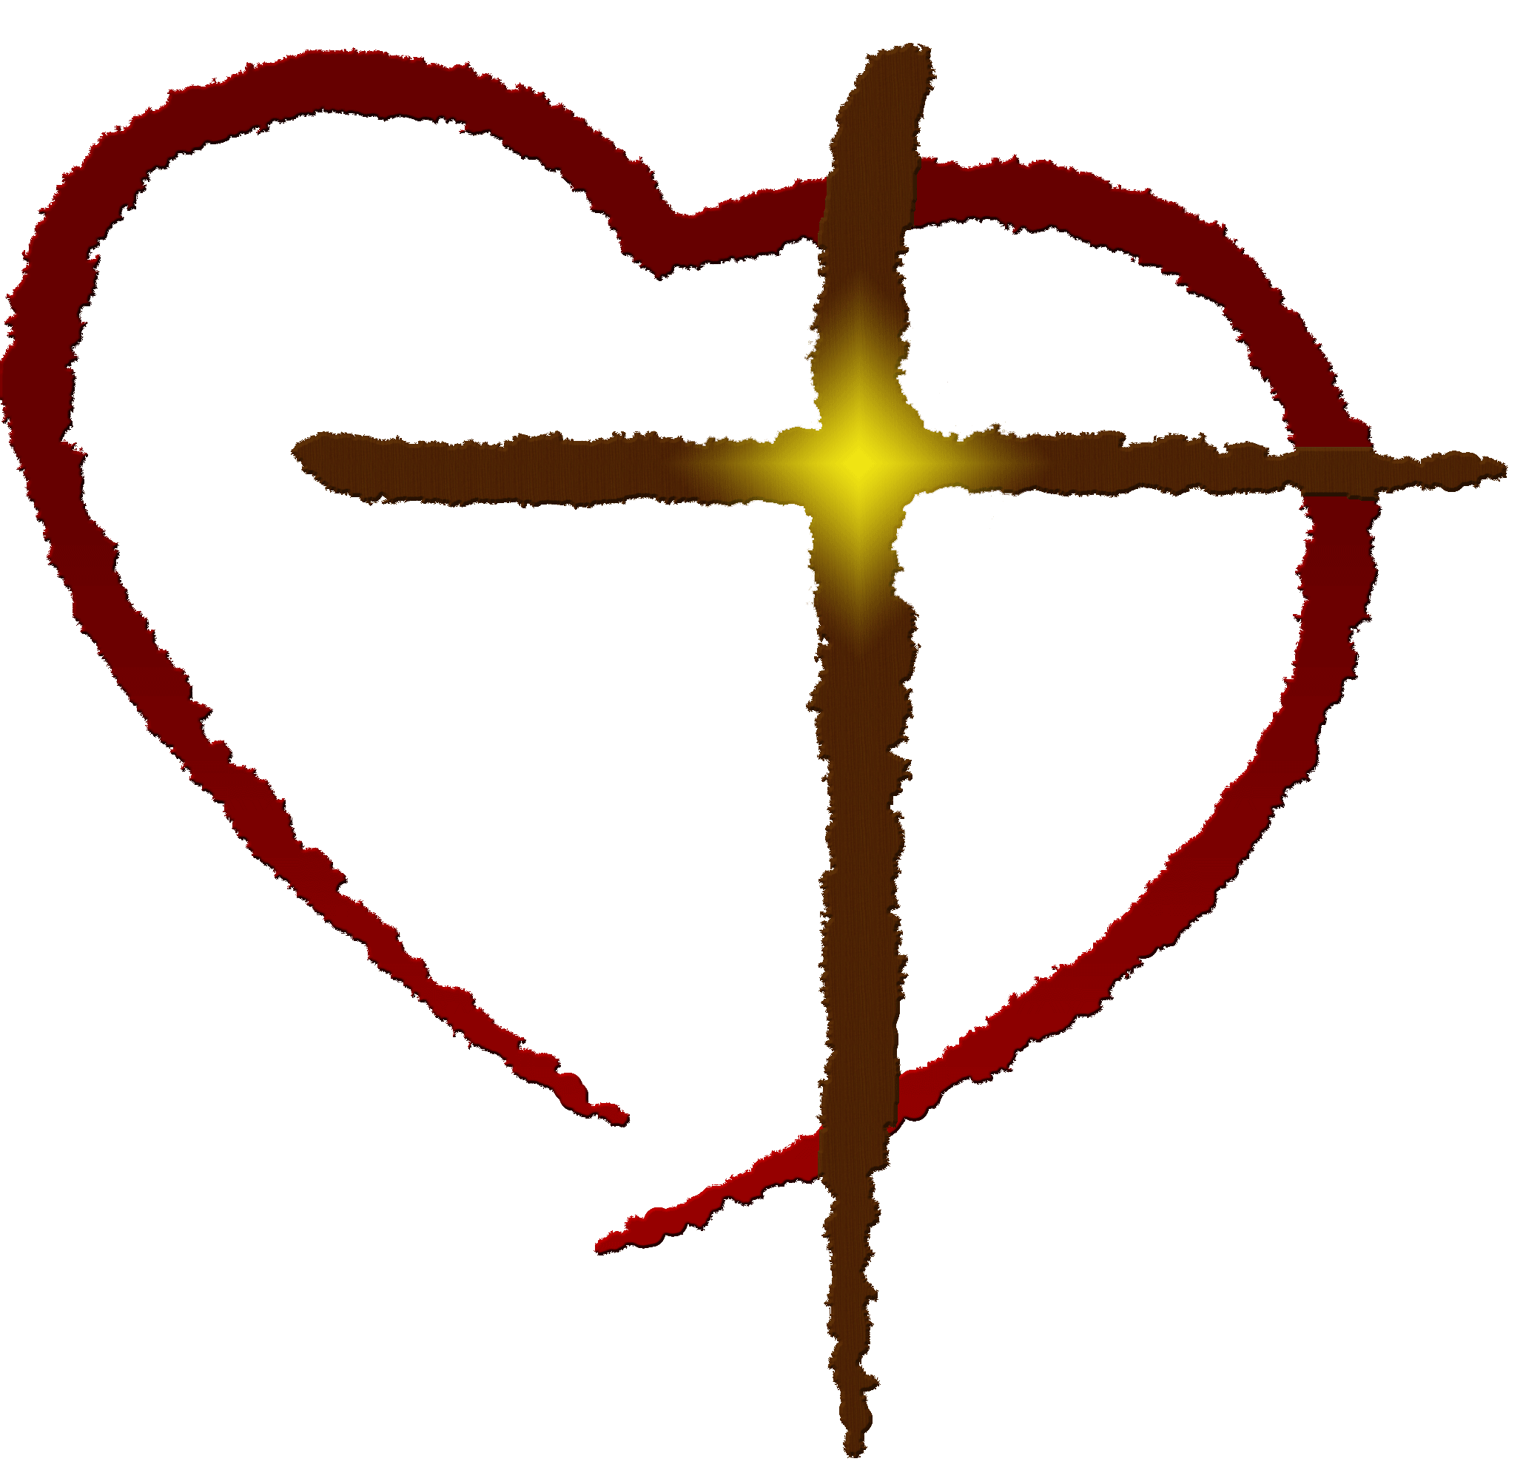

Pledge Sheet 1
What do you spend in one month on your mortgage or rent? Can you divide that by 30 and give that 24 hour portion? What do you spend on food in a month? Divide it by 30. What do you spend on utilities, on fuel for your home and/ or vehicle, on proper clothing for the weather? Do you have cell phones, cable and internet? Divide the bills by 30. What does it cost you monthly to live your lifestyle? Can you give 24 hours’ worth of your monthly living costs to help our neighbors in need? Every penny raised will go directly to Community Action and our area Homeless Coalition.
Ask grandparents, neighbors and friends to do the same. It doesn’t take long to look at your books and do a little math. Every bit counts and together, our large and small amounts can go a long, long way.
Example: House Note: $1000
Car Note: $400
Utilities and Gas: $700
Food: $600
Miscellaneous: $300
(cell phone, new coat, hotel in Fargo or Minneapolis, etc.)
TOTAL monthly expenses: $3000 (conservative, right?!)
Using this example, the 24 hour portion or 1/30 of the total is $100.

Donations can be made in cash or by writing a check to:
Trinity Youth Lock-Out
Every dollar donated goes to Community Action and Area 6 Homeless Coalition

Pledge Sheet 2
Participant Name______________________________________________

Donations can be made in cash or by writing a check to:
Trinity Youth Lock-Out

Name | Pledge
1.
2.
3.
4.
5.
6.
7.
8.
9.
10.
11.
12.
13.
14.
15.
16.
17.
18.
19.
20.

Contact Person: Kirstie Dobson
Director of Youth Ministries
Trinity Lutheran Church, Jamestown, ND
kirstiedobson@yahoo.com
Pledge Sheet 3
Parental Consent and Waiver for Participation
I, the parent or guardian of , a minor child referred to hereinafter as “Minor”, give my voluntary consent to Minor’s participation in the 2017 Youth Lock-Out Event (the “Event”) hosted by Trinity Lutheran Church (the “Hosts”), from May20-21, 2017, for the benefit of hunger and poverty issues.
As Minor’s parent or guardian, I assume responsibility for all of Minor’s actions while traveling to and/or from the event, and/or while engaged in the event, including any stops or breaks during the event.
I am fully aware of the risks and hazards connected with Minor’s participation in this event, and I VOLUNTARILY ASSUME FULL RESPONSIBILITY FOR ANY RISKS OR LOSS, PROPERTY DAMAGE, OR PERSONAL INJURY, INCLUDING DEATH, that may be sustained by Minor, or loss or damage to property owned by me or Minor, as a result of participation in the event. I understand that in the event of an accident, injury, illness or other emergency involving Minor, the Hosts will contact me and appropriate health care providers immediately, but that the Hosts do not otherwise assume any responsibility or obligation to provide medical assistance, financial assistance, or other assistance, including but not limited to, medical, health, or disability insurance, in the event of an accident, injury, illness, death or property damage involving Minor.
I hereby RELEASE, WAIVE, and DISCHARGE the Hosts, their Board of Directors, officers, agents, employees, and volunteers from any and all liability, claims, demands, and causes of action whatsoever arising out of or related to any loss, damage, or injury, including death, that may be sustained by Minor, or to any property belonging to me or Minor, while participating in physical activity during the event.
Further, I hereby indemnify and hold harmless the Hosts, their Board of Directors, officers, agents, employees, and volunteers from any and all liability, claims, demands, and causes of action brought against the Hosts by a third party and arising out of any loss, damage, or injury, including death, directly caused by Minor’s actions, regardless of whether such actions result from inadvertence, negligence, or intentional wrongdoing.
I also understand that photos will be taken during this event. I grant the hosts the irrevocable and unrestricted right to use and publish any photographs taken of the Minor, or in which they may be included, for editorial, trade, advertising, and any other purpose and in any manner and medium; and to alter and composite the same without restriction and without my inspection or approval. I hereby release the Hosts and their legal representatives and assigns from all claims and liability relating to said photographs.
In signing this release and liability waiver form, I acknowledge that I HAVE READ THE FORGOING, UNDERSTAND IT AND SIGN IT VOLUNTARILY as my own free act and deed.

Signature of Parent/Guardian Date

( )

Printed Name of Parent/Guardian Emergency Phone Number

Printed Name of Minor **Please list any health concerns/allergies on the reverse side of this form.

Adult Waiver and Assumption of Risk
I, , have voluntarily agreed to participate in the 2017 Youth Lock-Out Event (the “Event”) hosted by Trinity Lutheran Church, Jamestown ND (the “Church”), from May 20-21, 2017, for the benefit of hunger and poverty issues.
I assume responsibility for all of my actions while traveling to and/or from the event, and/or while engaged or participating in the event, including any stops or breaks during the event.
I am fully aware of the risks and hazards connected with my participation in this event, and I VOLUNTARILY ASSUME FULL RESPONSIBILITY FOR ANY RISKS OR LOSS, PROPERTY DAMAGE, OR PERSONAL INJURY, INCLUDING DEATH, that I may sustain, or loss or damage to property owned by me, as a result of participation in the event. I understand that in the event of an accident, injury, illness or other emergency involving me, the Church will contact appropriate health care providers immediately, but that the Church does not otherwise assume any responsibility or obligation to provide medical assistance, financial assistance, or other assistance, including but not limited to, medical, health, or disability insurance, in the event of an accident, injury, illness, death or property damage involving me.
I hereby RELEASE, WAIVE, and DISCHARGE the Church, its Board of Directors, its officers, agents, employees, and volunteers from any and all liability, claims, demands, and causes of action whatsoever arising out of or related to any loss, damage, or injury, including death, that may be sustained by me, or to any property belonging to me, while participating in physical activity during the event.
Further, I hereby indemnify and hold harmless the CHURCH, its Board of Directors, its officers, agents, employees, and volunteers from any and all liability, claims, demands, and causes of action brought against the Church by a third party and arising out of any loss, damage, or injury, including death, directly caused by my actions, regardless of whether such actions result from inadvertence, negligence, or intentional wrongdoing.
In signing this release and liability waiver form, I acknowledge that I HAVE READ THE FORGOING, UNDERSTAND IT AND SIGN IT VOLUNTARILY as my own free act and deed.

Signature of Participant Date
( )
Printed Name of Participant Emergency Phone Number
Please list any health concerns/allergies on the reverse side of this form

